**Ideation Phase**

**Brainstorm & Idea Prioritization Template**

|  |  |
| --- | --- |
| Date | 19 November 2023 |
| Team ID | 591569 |
| Project Name | Machine Learning Approach for Predicting the Rainfall |
| Maximum Marks | 4 Marks |

**Brainstorm & Idea Prioritization:**

In developing a machine learning approach for predicting rainfall, a strategic brainstorm and idea prioritization are crucial for success. Beginning with meticulous data collection and preprocessing, the focus extends to feature engineering, selecting appropriate models, and evaluating their performance. Interpretability and the ability to explain predictions add a layer of transparency to the project. Deployment and accessibility are paramount, involving the creation of user-friendly interfaces and seamless integration options. Prioritization emphasizes data quality, feature engineering, robust model selection, interpretability, deployment, and a commitment to continuous improvement through feedback loops. This structured approach ensures a comprehensive and effective solution for predicting rainfall through machine learning.

**Link:** https://app.mural.co/t/project7866/m/project7866/1700412563949/57faf25035564f7d694d48c6e6420842fdadd735?sender=ude4d8d19c014ec7af2502383

**Step-1: Team Gathering, Collaboration and Select the Problem Statement**

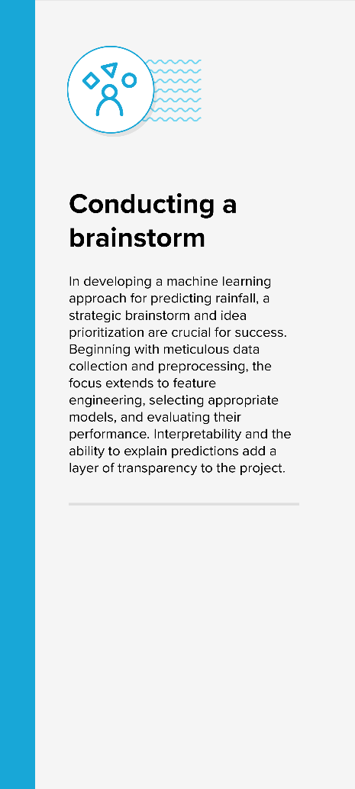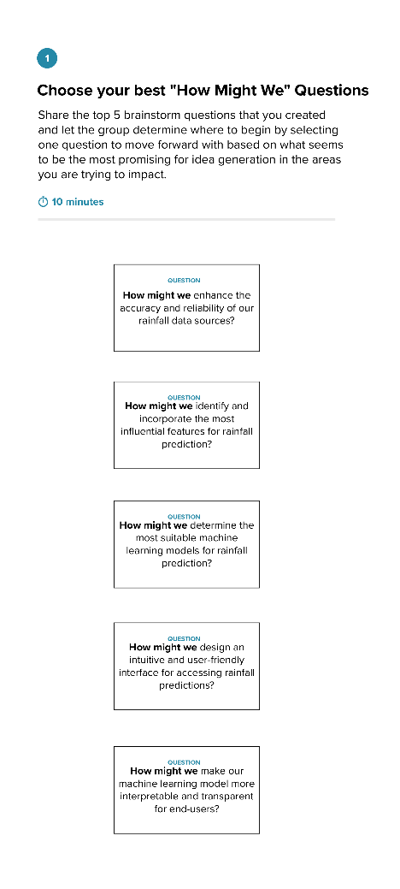

**Step-2: Brainstorm Solo**

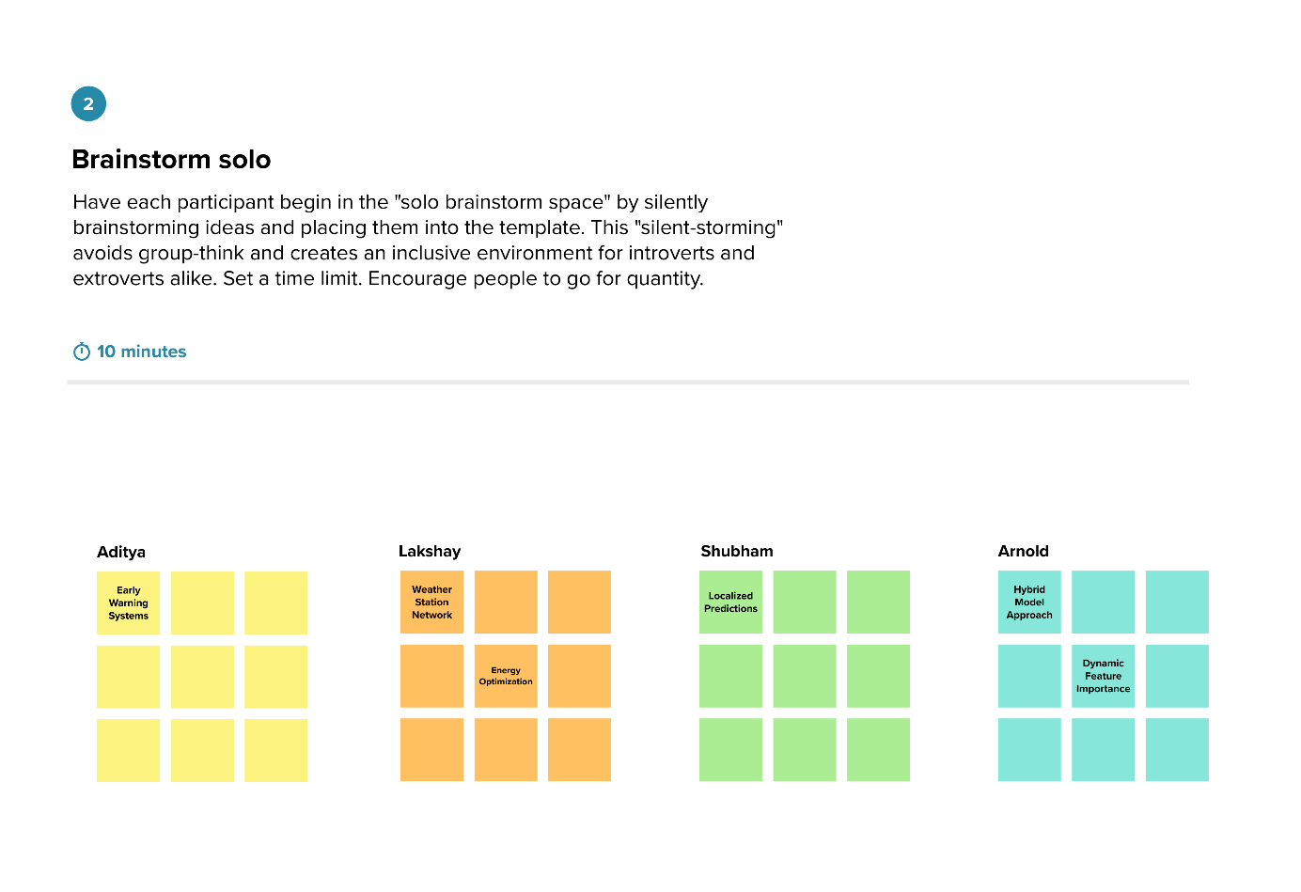

**Step-3: Brainstorm as a Group**

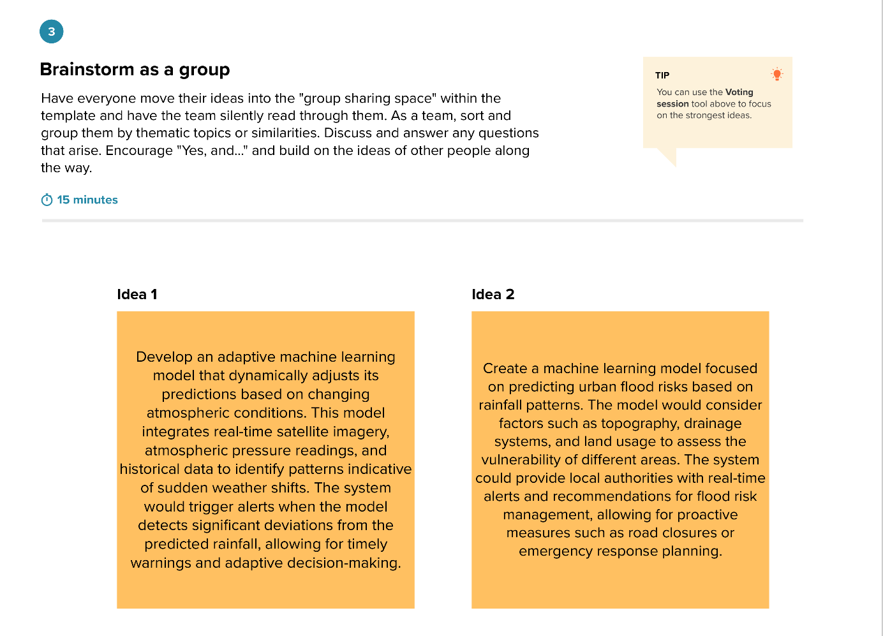

**Step-4: Idea Prioritization and deciding focus**

